NFC Labwork Tutorial

1. Install the latest Arduino IDE from the link below:

<https://www.arduino.cc/en/Main/Software>

1. Install the driver of the USB Serial driver CH340

<https://learn.sparkfun.com/tutorials/how-to-install-ch340-drivers/all#windows-710>

1. Run the Arduino IDE and configure the “Tools” with the following setting:

* Board >> Arduino Nano
* Processor>>ATMega328P (Old Bootloader)
* Port>> “Please check COM port from the device manager”
* Programmer>>Arduino as ISP

1. Change the dipswitch of the PN532 Module to the I2C Mode

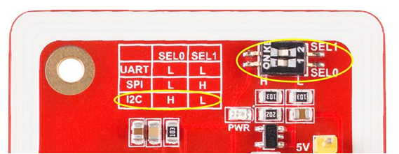

1. Connect the PN532 Module to the Arduino Nano 328P with the following connection.

|  |  |
| --- | --- |
| **PN532** | **Arduino Nano** |
| GND | GND |
| 5V | 5V |
| SDA | A4 |
| SCL | A5 |

1. Download the sketch library of the PN532 from your email or ask the Labor Assistant for it.
2. To avoid multiple library of the I2C Library, please rename the file “Wire.h” in the folder C:\Program Files (x86)\Arduino\hardware\arduino\avr\libraries\Wire\src. For example, you can rename it with “WireX.h”
3. Please edit the “nfc.h” file in the directory >> C:\Program Files (x86)\Arduino\libraries\nfc-pn532-master by commenting line 42. It will be look like this below:

#ifndef __TYPE_REDEFINE

#define __TYPE_REDEFINE

typedef uint8_t u8;

typedef int8_t s8;

//typedef uint16_t u16; >>> it makes an compiling error

typedef int16_t s16;

typedef uint32_t u32;

typedef int32_t s32;

#endif

1. Run the Arduino IDE and find the sketch example for the NFC-PN532
2. Compile the program and check it with the Serial Monitoring Tool (baud rate>>9600 bps) of the Arduino IDE Software

HAVE FUN!!!